**Steps to assign mechanical key to keypad in Delious Machine**

* + - 1. Go to MENU > PROGRAMMING > PRESET. Tap on Mechanical Key

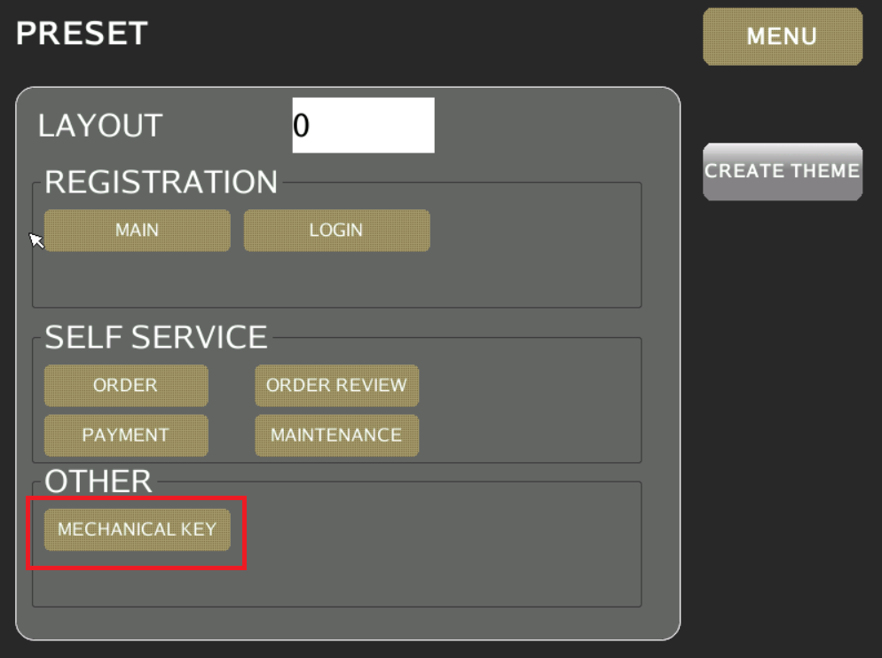

* + - 1. Tap on the highlighted to choose Preset key group

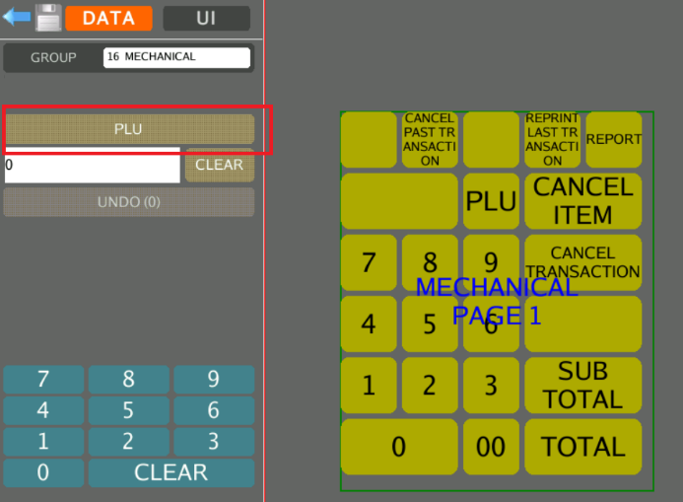

* + - 1. A list of PRESET KEY group displayed.

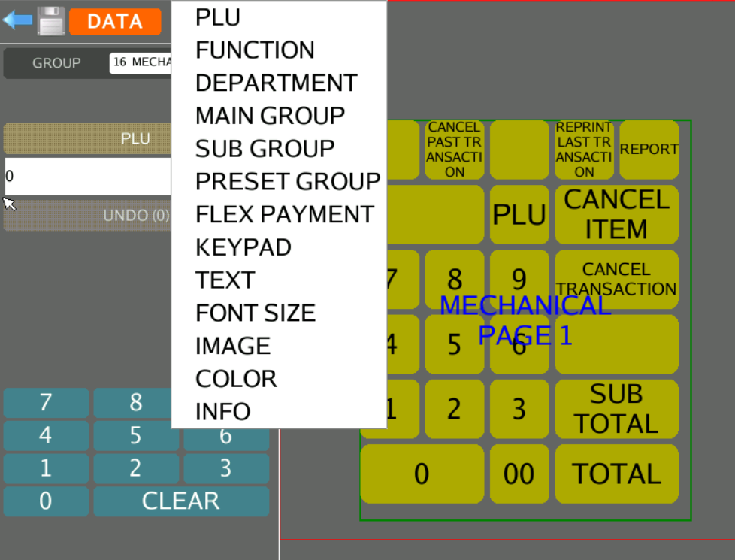

* + - 1. Sample of assigning preset key to mechanical key pad. E.g. Assign 30008 PLU to the assigned key pad

